Ideation Phase

Define the Problem Statements

Date | 26 September 2026
Team ID | SWTID-2026-5289
Project Name | AI STUDYBUDDY API
Maximum Marks | 3 Marks
Customer Problem Statement Template:
Create a problem statement to understand your customer's point of view. The Customer Problem Statement template helps you focus on what matters to create experiences people will love.
A well-articulated customer problem statement allows you and your team to find the ideal solution for the challenges your customers face. Throughout the process, you’ll also be able to empathize with your customers, which helps you better understand how they perceive your product or service.
Example:
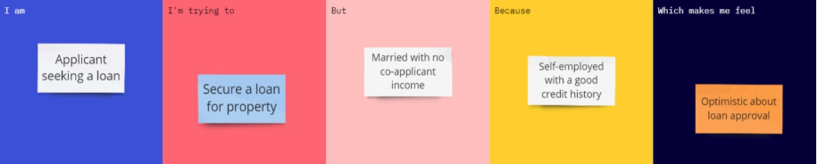
Problem Statement (PS) | I am (Customer) | I’m trying to | But | Because |  | Which makes me feel
PS-1 | A college student | Manage my study schedule and prepare for exams effectively | I find it difficult to plan my study time and organize different subjects | I don't have a personalized study plan based on my subjects, available time, and progress | Stressed, confused, and less confident about my preparation
PS-2 | A college student | Understand difficult topics and clear my doubts | I cannot always get immediate help when I have doubts | Teachers or other learning resources may not be available whenever I need them | Frustrated and worried about my studies

